School Of computing

Practical 3: Data Types and Operators

What you will learn / do in this lab

- Use data types and operators
- Capture user input
- Perform simple computations
- Display output using console.log
ST0502 Fundamentals of Programming

- Write a program using only print to output the following (refer to Appendix-A for the program flowchart):

Module Code\Name: STxxxx\"Fundamentals of Programming"
CA 1 :40%
CA 2 :20%
EXAM :40%
Total---------->:100%

- Write a program to implement the following algorithm (declare all necessary variables) (refer to Appendix-B for the program flowchart):
Step 1: assign 20 to x
Step 2: assign 5 to y
Step 3: compute the product of x and y, store it in
z
Step 4: display the value of x, y and z

Sample output:
x : 20
y : 5
z : 100

3. Write codes for the incomplete program below so that it sums up all the digits in the integer variable num (9+3+2) and displays the output as shown below.

Hint: Use the % operator and Math.floor() function to extract the digits.

(refer to Appendix-C for the program flowchart)
var num = 932;
var digit1; //to extract 9
var digit2; //to extract 3
var digit3; //to extract 2
var sum; //sum of all digits

// Missing part (a)

// Missing part (b)

// Missing part (c)
// Missing part (d)

// Missing part (e)

Program output:
num: 932
digit1: 9
digit2: 3
digit3: 2
sum: 14

- Extract the 1st digit (9) from num and assign it to digit1
Hint : num divided by 100.

- Extract the 3rd digit (2) and assign it to digit3.
Hint :Get the remainder of num divided by 10.

- Extract the 2nd digit (3) from num and assign it to digit2.
Hint: num divided by 10 (get 93) and get the remainder of 93 divided by 10.

- Compute sum.

- Display the program output

4. A year is a leap year if it is divisible by 4 but not by 100, or it is divisible by 400.

In other words, a leap year can be evaluated using the boolean expression:
( (divisible by 4) and (not divisible by 100) ) or (divisible by 400)

Program output
1996 is a leap year? true
1990 is a leap year? false

Write a program that does the following:
- Declare integer variables year1 and year2 and assign 1996 and 1900 to the 2 variables respectively.
- Declare a boolean variable isLeapYear.
- Evaluate whether year1 is a leap year and assign the boolean result to isLeapYear.
- Display the result for year1.
- Repeat the previous 2 steps for year2.

(refer to Appendix-D for the program flowchart)

- Write a program that prompts the user for his name and displays a personalized message to the user as shown below (refer to Appendix-E for the program flowchart).

Program output:
Enter your name: Jes
Jes loves Programming!

6. Write a program that prompts the user for two integers. The 2 integers are added and the result is displayed. Your program should also be able to determine if the 1st integer is divisible by the 2nd integer.

Program output
Enter first number: 21
Enter second number: 7

Here are the result…

21 + 7 = 28
21 divisible by 7? true

(refer to Appendix-F for the program flowchart)

7. Write a program that converts Fahrenheit to Celsius. The formula for the conversion is as follows:

Celsius = 5/9 * (Fahrenheit - 32)

Your program reads a Fahrenheit degree from the input dialog box, then converts it to Celsius and displays the result in a dialog box.

Here are steps involved:

- Prompt the user to enter the temperature in Fahrenheit

- Compute the temperature in Celsius. Remember to apply the appropriate type casting for the conversion formula.

- Display the temperature in Celsius

Program output
Enter Temperature in Fahrenheit: 95

Temperature in Celsius: 35

(refer to Appendix-G for the program flowchart)

[Optional Questions]

8. Write a program that computes distance between 2 coordinates.

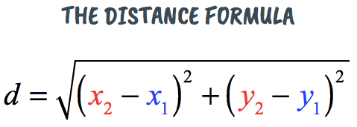

Program output:
Enter X1: 25
Enter Y1: 15
Enter X2: 35
Enter Y2: 10

The distance between (25,15) and (35,10) is 11.1803.

9. Write a program to read an amount of money (integer value) and break the amount into smallest possible number of bank notes. Assume that $1 notes still exist today.

Program output:
Enter Amount ($): 3378

3 Note(s) of 1000.00
3 Note(s) of 100.00
1 Note(s) of 50.00
2 Note(s) of 10.00
1 Note(s) of 5.00
1 Note(s) of 2.00
1 Note(s) of 1.00

10. Write a program to find the third angle (in degree) of a triangle if two angles are given.

Program output:
First Angle: 33
Second Angle: 56

The third angle is 91 degrees.

Appendix-A: Flowchart for Question-1
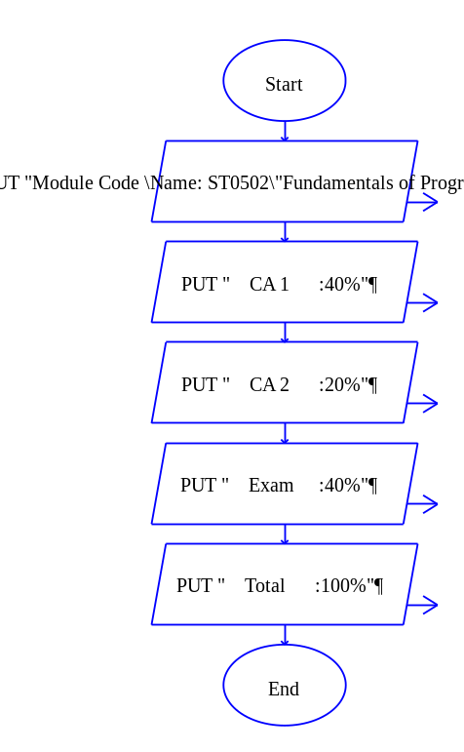

Appendix-B: Flowchart for Question-2
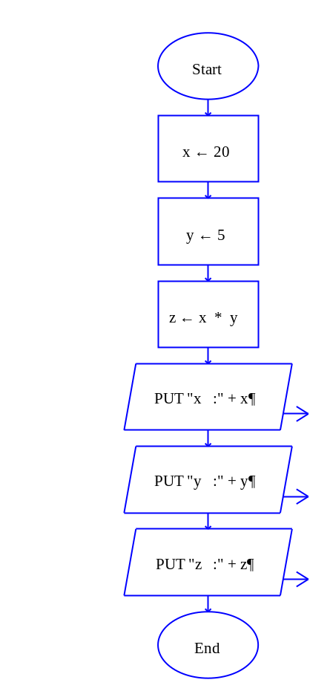

Appendix-C: Flowchart for Question-3
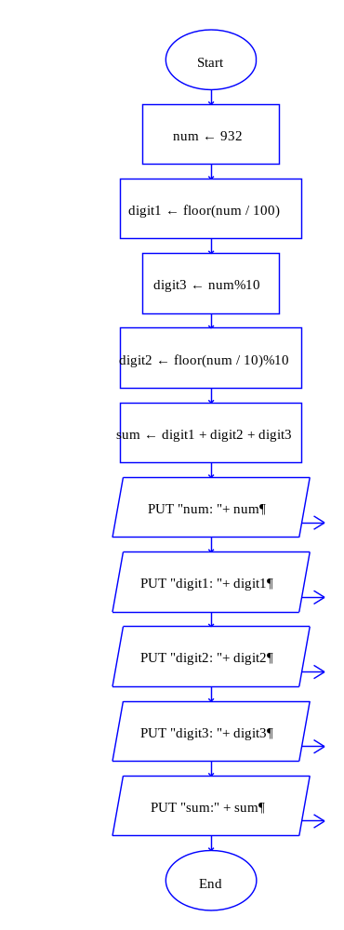
Appendix-D: Flowchart for Question-4
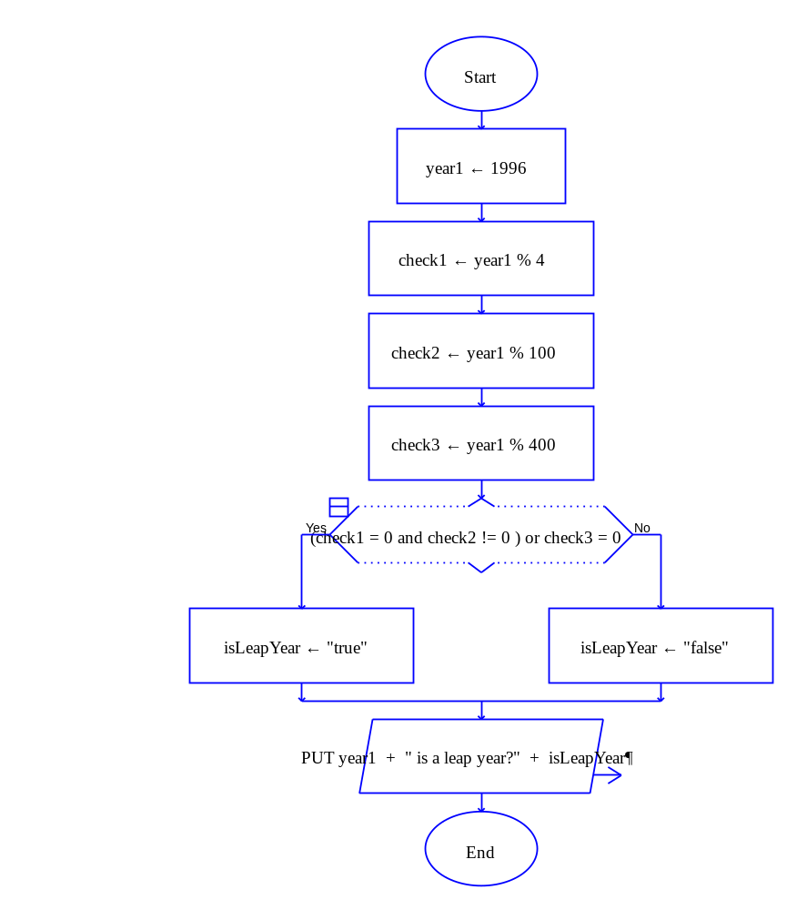
Appendix-E: Flowchart for Question-5
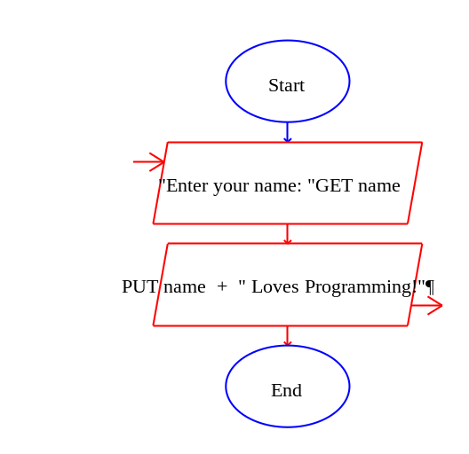
Appendix-F: Flowchart for Question-6
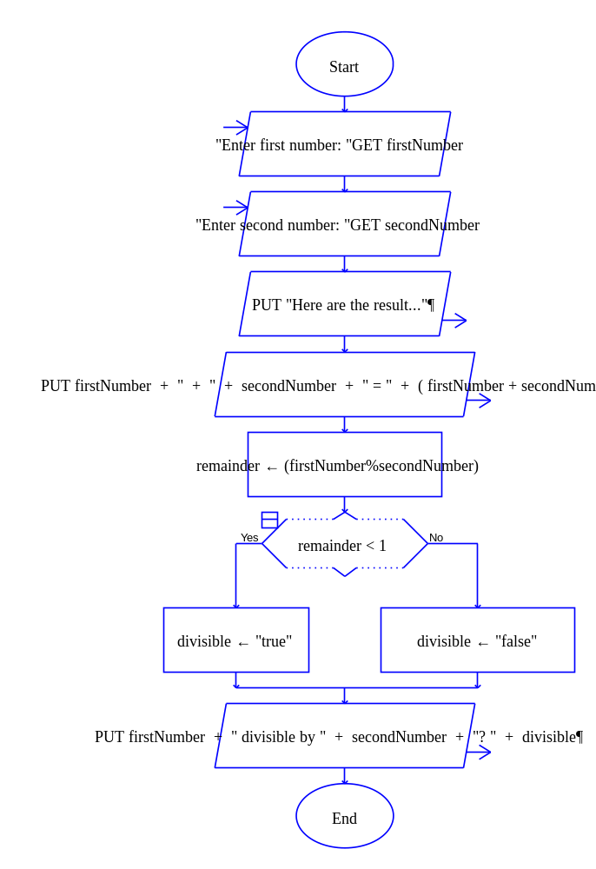
Appendix-G: Flowchart for Question-7
